Chapter-1

Study of Existing system and system requirements.
Hardware & Software Requirement:

Hardware Interfaces
- Minimum Hardware requirement
- Processor: P4 3.0 GHz
- RAM:1 GB or Higher
- Monitor
- Mouse
- Hard disk: 80 GB

Software Interfaces
- Minimum Software requirement
- Spring Boot
- Spring MVC
- Java (JSP and Servlet)

- Apache Tomcat Server
All these types of software automatic configure inside operating system after installation it having Java, MYSQL, Apache and operating system base configuration file, it doesn’t need to configure manually.
Introduction

As we know, today online booking is becoming popular day by day whether it is hotel booking or flight booking or anything. So, I have developed a home stay application where an owner can give the houses for booking and user can book the home also can select the tour package for a specific period.
This application is designed for all types of user whether it is admin, owner and user. The user here has the facility of booking homes, tour for specific period of time. The owner here is the role whose responsibility is to add Home Stays for user, also add tour packages and etc. The last role is that of admin who will see the help and feedback reports.
This application will not only help the users but also the owner and he/she both can have a common medium to be connected.

Objective
The main objective of this project is to provide a good application where travelers can book rooms on a computer and also can compare prices. It will remove the manual way of booking to an automated system.

Here, Admin who views all the help, feedback reports, the owner can add Home stays, Room, Tour package. The user who can book the rooms, home stays of their choice. .

Methodologies

There are three main users of this application one is the Admin, the other is the Owner and the last one is User.
1) Admin
- Admin can VIEW/UPDATE/ADD the Help Solution.
- Admin can ADD/VIEW/DELETE/UPDATE feedback questions.
- Admin can VIEW feedback added by User.
- Admin can VIEW its profile.
2) Owner
- Owners can ADD/VIEW/UPDATE/DELETE Home stays.
- Owners can ADD/VIEW/UPDATE/DELETE Rooms.
- Owner can ADD/VIEW/UPDATE/DELETE Tour package.
- Owner can VIEW/PRINT the Home stays booking.
- Owner can VIEW/PRINT the Tour Booking report.
- Owner can ADD/VIEW the Help report.
- Owner can VIEW its profile.
3) User
- User can VIEW Home Stays
- User can VIEW Tour packages.
- Users can VIEW Room available.
- User can BOOK/VIEW the Home stay.
- User can BOOK/VIEW the tour.
- User can ADD/VIEW the help.
- User can add the feedback.
Note: The login, registration and change password is common to all the user in the system.

Chapter-2
System Analysis
2.1 E R DIAGRAM
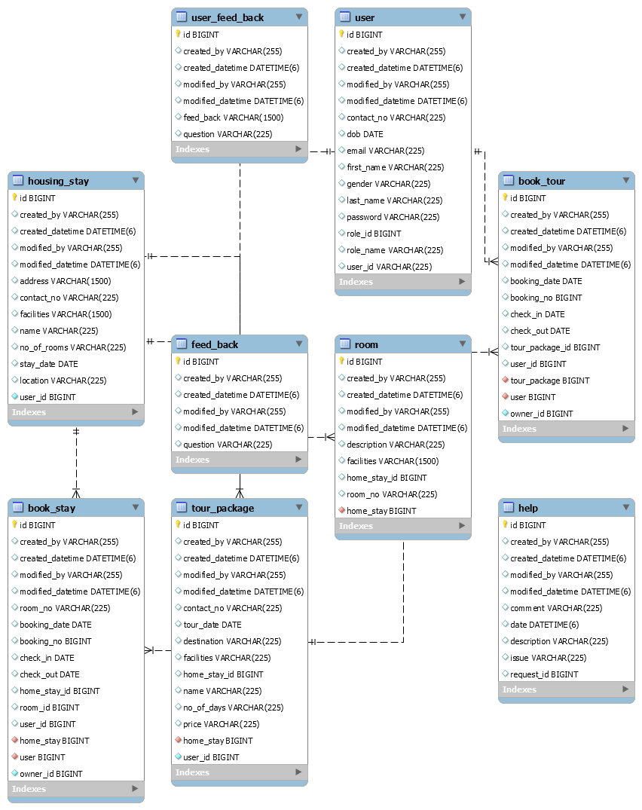

Data Flow Diagram (DFD)
Level 0:
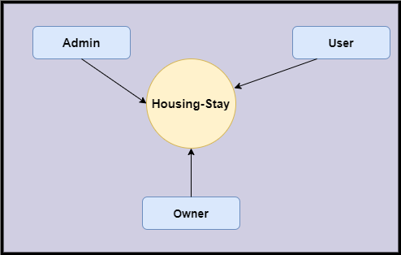
Level 1
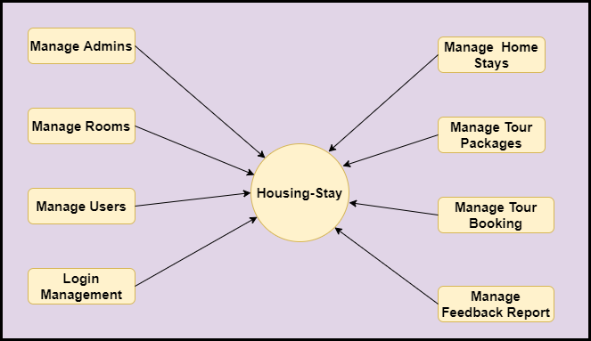

Level 2-DFD Admin
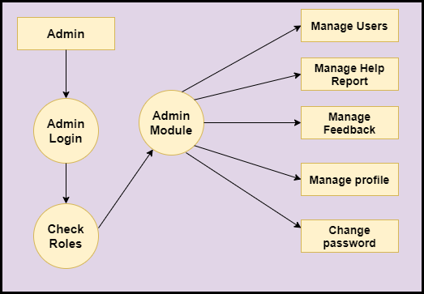
Level 2-DFD Owner
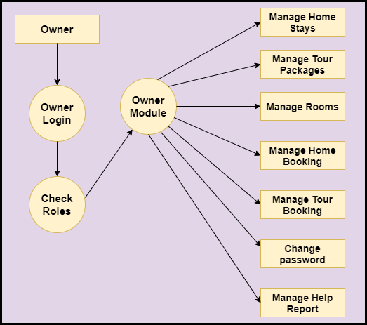
Level 2-DFD User
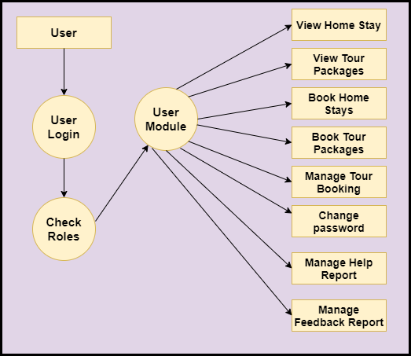

Feasibility:
This project will be developed on computer, so first check whether the technology is technically available or not. Now a day’s computer interaction with any job becomes common for any kind of job or work.

And because of increasing usage of Computer, Computer is also available with a variety of hardware. Vendors can fulfill any type of hardware requirement. The whole project is developed by some special tools or by using languages and databases, which are also available in a variety.

Preliminary investigation of a system examines the feasibility of a system that is useful to an organization. It is the first phase of system development.

The main objective of this phase is to identify the current deficiencies in the user’s environment and to determine which existing problem are going to be solve in proposed system and also which new function needs to be added in proposed system.

An important outcome of such preliminary investigation is to determine whether the system that will meet all needed requirements.

Thus, three tests are carried out on the system namely operation, technical and economical.

Any project is beneficial if and only satisfies the organization requirement. For any new system setup, it only meets to be communicated and work the other supporting system.

The new system meets all existing operations since it provides right information at a right time to the right user. A Leigh man can easily operate with the system.

Technical Feasibility examines whether the technology needed is available and if it is available then it feasible to carry out all project activities.

The technical needs of a system include:

- The facility to produce outputs in a given time.
- Ability to process large number of transaction at a particular speed.
- Giving response to users under certain conditions.

The technology needed for our system is mainly:

- Latest version of browsers.
- Any operating system.

These technologies are available which helps to carry out the system efficiently.

Economical feasibility of a system examines whether the finance is available for implementing the new system and whether the money spent is recoverable the satisfaction.

The cost involves is in designing and developing a good investment for the organization.

Thus, hardware requirements used for proposed system are very standard. Moreover, by making use of proposed system to carry out the work speedily will increase and also saves the valuable time of an organization.

In the proposed system the finance is highly required for the installation of the software’s which can also be recovered by implementing a better system.
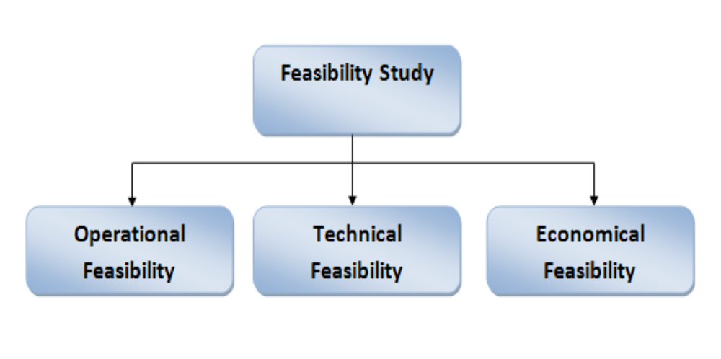

Chapter-3
Design
System Flow Chart:
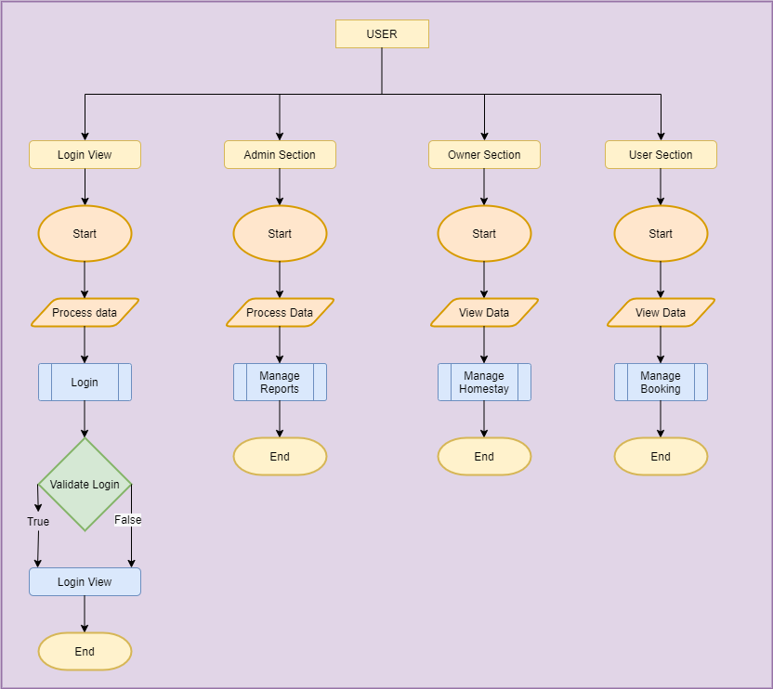

Data dictionary
Data validation:
Procedures are designed to detect errors in data at a lower level of detail. Data validations have been integrated in the system in almost every area where there is a possibility for the user to commit errors. The system will not recognize invalid data.
Whenever an invalid data is keyed in, the system immediately prompts the user and the user has to again key in the data and the system will accept the data only if the data is correct. Validations have been integrated where necessary.
The system is designed to be a user friendly one. In other words the system has been designed to communicate effectively with the user. The system has been designed with pop up menus.

Different Type Of validation:
- Data type validation;
- Range and constraint validation;
- Code and Cross-reference validation; and
Structured validation

Coding

DTO:
UserDTO:
package com.housing.stay.dto;

import java.util.Date;
import java.util.Set;

import javax.persistence.CascadeType;
import javax.persistence.Column;
import javax.persistence.Entity;
import javax.persistence.OneToMany;
import javax.persistence.Table;
import javax.persistence.Temporal;
import javax.persistence.TemporalType;
import javax.persistence.Transient;

import lombok.Getter;
import lombok.Setter;

@Entity
@Table(name = "USER")
@Getter
@Setter
public class UserDTO extends BaseDTO {

@Column(name = "FIRST_NAME", length = 225)
private String firstName;

@Column(name = "LAST_NAME", length = 225)
private String lastName;

@Column(name = "USER_ID", length = 225)
private String userId;

@Column(name = "PASSWORD", length = 225)
private String password;

@Transient
private String confirmPassword;

@Column(name="DOB")
@Temporal(TemporalType.DATE)
private Date dob;

@Column(name = "GENDER", length = 225)
private String gender;

@Column(name = "CONTACT_NO", length = 225)
private String contactNo;

@Column(name = "EMAIL", length = 225)
private String email;

@Column(name = "ROLE_ID")
private long roleId;

@Column(name = "ROLE_NAME", length = 225)
private String roleName;

@OneToMany(cascade = CascadeType.ALL,mappedBy = "user")
private Set<BookStayDTO> bookStays;

public String getKey() {
return id + "";
}

public String getValue() {

return firstName + " " + lastName;
}

}
RoomDTO:
package com.housing.stay.dto;

import javax.persistence.Column;
import javax.persistence.Entity;
import javax.persistence.JoinColumn;
import javax.persistence.ManyToOne;
import javax.persistence.Table;

import lombok.Getter;
import lombok.Setter;

@Entity
@Table(name="ROOM")
@Getter
@Setter
public class RoomDTO extends BaseDTO {

@Column(name="ROOM_NO",length = 225)
private String roomNo;
@Column(name="FACILITIES",length = 1500)
private String facilities;
@Column(name="DESCRIPTION",length = 225)
private String description;

@Column(name="HOME_STAY_ID",length = 225)
private long homeStayId;

@ManyToOne
@JoinColumn(name="HOME_STAY",nullable = false)
private HomeStayDTO homeStay;

@Override
public String getKey() {
return String.valueOf(id);
}

@Override
public String getValue() {
return roomNo;
}

}
BookStayDTO:
package com.housing.stay.dto;

import java.util.Date;

import javax.persistence.Column;
import javax.persistence.Entity;
import javax.persistence.JoinColumn;
import javax.persistence.ManyToOne;
import javax.persistence.Table;
import javax.persistence.Temporal;
import javax.persistence.TemporalType;
import javax.persistence.Transient;

import lombok.Getter;
import lombok.Setter;

@Getter
@Setter
@Entity
@Table(name="BOOK_STAY")
public class BookStayDTO extends BaseDTO {

@Column(name="BOOKING_NO")
private long bookingNo;

@Column(name="USER_ID")
private long userId;

@Column(name="HOME_STAY_ID")
private long homeStayId;

@ManyToOne
@JoinColumn(name="USER",nullable = false)
private UserDTO user;

@ManyToOne
@JoinColumn(name="HOME_STAY",nullable = false)
private HomeStayDTO homeStay;

@Column(name="CHECK_IN")
@Temporal(TemporalType.DATE)
private Date checkIn;

@Column(name="CHECK_OUT")
@Temporal(TemporalType.DATE)
private Date checkOut;

@Column(name="ROOM_ID")
private long roomId;

@Column(name="ROOM_NO",length = 225)
private String RoomNo;

@Column(name="BOOKING_DATE")
@Temporal(TemporalType.DATE)
private Date bookingDate;

@Transient
private Date fromDate;

private long ownerId;

@Override
public String getKey() {
// TODO Auto-generated method stub
return null;
}

@Override
public String getValue() {
// TODO Auto-generated method stub
return null;
}

}
BookTourDTO:
package com.housing.stay.dto;

import java.util.Date;

import javax.persistence.Column;
import javax.persistence.Entity;
import javax.persistence.JoinColumn;
import javax.persistence.ManyToOne;
import javax.persistence.Table;
import javax.persistence.Temporal;
import javax.persistence.TemporalType;
import javax.persistence.Transient;

import lombok.Getter;
import lombok.Setter;

@Getter
@Setter
@Entity
@Table(name="BOOK_TOUR")
public class BookTourDTO extends BaseDTO {

@Column(name="BOOKING_NO")
private long bookingNo;

@Column(name="USER_ID")
private long userId;

@Column(name="TOUR_PACKAGE_ID")
private long tourId;

@ManyToOne
@JoinColumn(name="USER",nullable = false)
private UserDTO user;

@ManyToOne
@JoinColumn(name="TOUR_PACKAGE",nullable = false)
private TourPackageDTO tourPackage;

@Column(name="CHECK_IN")
@Temporal(TemporalType.DATE)
private Date checkIn;

@Column(name="CHECK_OUT")
@Temporal(TemporalType.DATE)
private Date checkOut;

@Column(name="BOOKING_DATE")
@Temporal(TemporalType.DATE)
private Date bookingDate;

@Transient
private Date fromDate;

private long ownerId;

@Override
public String getKey() {
// TODO Auto-generated method stub
return null;
}

@Override
public String getValue() {
// TODO Auto-generated method stub
return null;
}

}
FeedBackDTO:
package com.housing.stay.dto;

import javax.persistence.Column;
import javax.persistence.Entity;
import javax.persistence.Table;

import lombok.Getter;
import lombok.Setter;

@Entity
@Table(name="FEED_BACK")
@Getter
@Setter
public class FeedBackDTO extends BaseDTO{

@Column(name="QUESTION",length = 225)
private String question;

@Override
public String getKey() {
return null;
}

@Override
public String getValue() {
return null;
}

}
HomeStayDTO:
package com.housing.stay.dto;

import java.util.Date;
import java.util.Set;

import javax.persistence.CascadeType;
import javax.persistence.Column;
import javax.persistence.Entity;
import javax.persistence.OneToMany;
import javax.persistence.Table;
import javax.persistence.Temporal;
import javax.persistence.TemporalType;

import lombok.Getter;
import lombok.Setter;

@Entity
@Table(name="HOUSING_STAY")
@Getter
@Setter
public class HomeStayDTO extends BaseDTO {

@Column(name="NAME",length = 225)
private String name;

@Column(name="CONTACT_NO",length = 225)
private String contactNo;

@Column(name="ADDRESS",length = 1500)
private String address;

@Column(name="NO_OF_ROOMS",length = 225)
private String noOfRooms;

@Column(name="FACILITIES",length = 1500)
private String facilities;

@Column(name="STAY_DATE")
@Temporal(TemporalType.DATE)
private Date date;

@Column(name="LOCATION",length = 225)
private String location;

@OneToMany(cascade = CascadeType.ALL,mappedBy = "homeStay")
private Set<TourPackageDTO> tourPackages;

@OneToMany(cascade = CascadeType.ALL,mappedBy = "homeStay")
private Set<RoomDTO> rooms;

@OneToMany(cascade = CascadeType.ALL,mappedBy = "homeStay")
private Set<BookStayDTO> bookStays;

private long userId;

@Override
public String getKey() {
return String.valueOf(id);
}

@Override
public String getValue() {
return name;
}

}

DAO:

UserDAOImpl
package com.housing.stay.dao;

import java.util.List;
import java.util.logging.Logger;

import javax.persistence.EntityManager;
import javax.persistence.NoResultException;

import org.hibernate.Criteria;
import org.hibernate.Session;
import org.hibernate.criterion.Restrictions;
import org.hibernate.query.Query;
import org.springframework.beans.factory.annotation.Autowired;
import org.springframework.stereotype.Repository;

import com.housing.stay.dto.UserDTO;

@Repository
public class UserDAOImpl implements UserDAOInt {

private static Logger log = Logger.getLogger(UserDAOImpl.class.getName());

@Autowired
private EntityManager entityManager;

@Override
public long add(UserDTO dto) {
log.info("UserDAOImpl Add method Start");
Session session = entityManager.unwrap(Session.class);
long pk = (long) session.save(dto);
log.info("UserDAOImpl Add method End");
return pk;
}

@Override
public void delete(UserDTO dto) {
log.info("UserDAOImpl Delete method Start");
entityManager.remove(entityManager.contains(dto) ? dto : entityManager.merge(dto));
log.info("UserDAOImpl Delete method End");

}

@Override
public UserDTO findBypk(long pk) {
log.info("UserDAOImpl FindByPk method Start");
Session session = entityManager.unwrap(Session.class);
UserDTO dto = (UserDTO) session.get(UserDTO.class, pk);
log.info("UserDAOImpl FindByPk method End");
return dto;
}

@Override
public UserDTO findByUserId(String userId) {
log.info("UserDAOImpl FindByLogin method Start");
Session session = entityManager.unwrap(Session.class);
Criteria criteria = session.createCriteria(UserDTO.class);
criteria.add(Restrictions.eq("userId",userId));
UserDTO dto = (UserDTO) criteria.uniqueResult();
log.info("UserDAOImpl FindByLogin method End");
return dto;
}

@Override
public void update(UserDTO dto) {
log.info("UserDAOImpl Update method Start");
Session session = entityManager.unwrap(Session.class);
session.merge(dto);
log.info("UserDAOImpl update method End");
}

@Override
public List<UserDTO> list() {
return list(0, 0);
}

@Override
public List<UserDTO> list(int pageNo, int pageSize) {
log.info("UserDAOImpl List method Start");
Session session = entityManager.unwrap(Session.class);
Query<UserDTO> query = session.createQuery("from UserDTO", UserDTO.class);
List<UserDTO> list = query.getResultList();
log.info("UserDAOImpl List method End");
return list;
}

@Override
public List<UserDTO> search(UserDTO dto) {
return search(dto, 0, 0);
}

@Override
public List<UserDTO> search(UserDTO dto, int pageNo, int pageSize) {
log.info("UserDAOImpl Search method Start");
Session session = entityManager.unwrap(Session.class);
StringBuffer hql = new StringBuffer("from UserDTO as u where 1=1 ");
if (dto != null) {
if (dto.getId() > 0) {
hql.append("and u.id = " + dto.getId());
}
if (dto.getRoleId() > 0) {
hql.append("and u.roleId = " + dto.getRoleId());
}

}
Query<UserDTO> query = session.createQuery(hql.toString(), UserDTO.class);
if (pageNo > 0) {
pageNo = (pageNo - 1) * pageSize;
query.setFirstResult(pageNo);
query.setMaxResults(pageSize);
}
List<UserDTO> list = query.getResultList();
log.info("UserDAOImpl Search method End");
return list;
}

@Override
public UserDTO authentication(UserDTO dto) {
log.info("UserDAOImpl Authentication method Start");
Session session = entityManager.unwrap(Session.class);
Query<UserDTO> query = session.createQuery("from UserDTO where userId=:login and password=:password",
UserDTO.class);
query.setParameter("login", dto.getUserId());
query.setParameter("password", dto.getPassword());
dto = null;
try {
dto = query.getSingleResult();
} catch (NoResultException nre) {
}
log.info("UserDAOImpl Authentication method End");
return dto;
}
}
HelpDAOImpl
package com.housing.stay.dao;

import java.util.List;
import java.util.logging.Logger;

import javax.persistence.EntityManager;

import org.hibernate.Criteria;
import org.hibernate.Session;
import org.hibernate.criterion.Restrictions;
import org.hibernate.query.Query;
import org.springframework.beans.factory.annotation.Autowired;
import org.springframework.stereotype.Repository;

import com.housing.stay.dto.HelpDTO;

@Repository
public class HelpDAOImpl implements HelpDAOInt {

private static Logger log = Logger.getLogger(HelpDAOImpl.class.getName());

@Autowired
private EntityManager entityManager;

@Override
public long add(HelpDTO dto) {
log.info("HelpDAOImpl Add method Start");
Session session = entityManager.unwrap(Session.class);
long pk = (long) session.save(dto);
log.info("HelpDAOImpl Add method End");
return pk;
}

@Override
public void delete(HelpDTO dto) {
log.info("HelpDAOImpl Delete method Start");
entityManager.remove(entityManager.contains(dto) ? dto : entityManager.merge(dto));
log.info("HelpDAOImpl Delete method End");

}

@Override
public HelpDTO findBypk(long pk) {
log.info("HelpDAOImpl FindByPk method Start");
Session session = entityManager.unwrap(Session.class);
HelpDTO dto = (HelpDTO) session.get(HelpDTO.class, pk);
log.info("HelpDAOImpl FindByPk method End");
return dto;
}

@Override
public HelpDTO findByIssue(String issue) {
log.info("HelpDAOImpl FindByLogin method Start");
Session session = entityManager.unwrap(Session.class);
Criteria criteria = session.createCriteria(HelpDTO.class);
criteria.add(Restrictions.eq("issue",issue));
HelpDTO dto = (HelpDTO) criteria.uniqueResult();
log.info("HelpDAOImpl FindByLogin method End");
return dto;
}

@Override
public void update(HelpDTO dto) {
log.info("HelpDAOImpl Update method Start");
Session session = entityManager.unwrap(Session.class);
session.merge(dto);
log.info("HelpDAOImpl update method End");
}

@Override
public List<HelpDTO> list() {
return list(0, 0);
}

@Override
public List<HelpDTO> list(int pageNo, int pageSize) {
log.info("HelpDAOImpl List method Start");
Session session = entityManager.unwrap(Session.class);
Query<HelpDTO> query = session.createQuery("from HelpDTO", HelpDTO.class);
List<HelpDTO> list = query.getResultList();
log.info("HelpDAOImpl List method End");
return list;
}

@Override
public List<HelpDTO> search(HelpDTO dto) {
return search(dto, 0, 0);
}

@Override
public List<HelpDTO> search(HelpDTO dto, int pageNo, int pageSize) {
log.info("HelpDAOImpl Search method Start");
Session session = entityManager.unwrap(Session.class);
StringBuffer hql = new StringBuffer("from HelpDTO as u where 1=1 ");
if (dto != null) {
if (dto.getId() > 0) {
hql.append("and u.id = " + dto.getId());
}

if (dto.getRequestId() > 0) {
hql.append("and u.requestId = " + dto.getRequestId());
}

if (dto.getIssue() !=null && dto.getIssue().length()>0) {
hql.append("and u.issue like '" + dto.getIssue()+"%'");
}

}
Query<HelpDTO> query = session.createQuery(hql.toString(), HelpDTO.class);
if (pageNo > 0) {
pageNo = (pageNo - 1) * pageSize;
query.setFirstResult(pageNo);
query.setMaxResults(pageSize);
}
List<HelpDTO> list = query.getResultList();
log.info("HelpDAOImpl Search method End");
return list;
}

}
FeedbackDAOImpl
package com.housing.stay.dao;

import java.util.List;
import java.util.logging.Logger;

import javax.persistence.EntityManager;

import org.hibernate.Criteria;
import org.hibernate.Session;
import org.hibernate.criterion.Restrictions;
import org.hibernate.query.Query;
import org.springframework.beans.factory.annotation.Autowired;
import org.springframework.stereotype.Repository;

import com.housing.stay.dto.FeedBackDTO;

@Repository
public class FeedBackDAOImpl implements FeedBackDAOInt {

private static Logger log = Logger.getLogger(FeedBackDAOImpl.class.getName());

@Autowired
private EntityManager entityManager;

@Override
public long add(FeedBackDTO dto) {
log.info("FeedBackDAOImpl Add method Start");
Session session = entityManager.unwrap(Session.class);
long pk = (long) session.save(dto);
log.info("FeedBackDAOImpl Add method End");
return pk;
}

@Override
public void delete(FeedBackDTO dto) {
log.info("FeedBackDAOImpl Delete method Start");
entityManager.remove(entityManager.contains(dto) ? dto : entityManager.merge(dto));
log.info("FeedBackDAOImpl Delete method End");

}

@Override
public FeedBackDTO findBypk(long pk) {
log.info("FeedBackDAOImpl FindByPk method Start");
Session session = entityManager.unwrap(Session.class);
FeedBackDTO dto = (FeedBackDTO) session.get(FeedBackDTO.class, pk);
log.info("FeedBackDAOImpl FindByPk method End");
return dto;
}

@Override
public FeedBackDTO findByIssue(String issue) {
log.info("FeedBackDAOImpl FindByLogin method Start");
Session session = entityManager.unwrap(Session.class);
Criteria criteria = session.createCriteria(FeedBackDTO.class);
criteria.add(Restrictions.eq("issue",issue));
FeedBackDTO dto = (FeedBackDTO) criteria.uniqueResult();
log.info("FeedBackDAOImpl FindByLogin method End");
return dto;
}

@Override
public void update(FeedBackDTO dto) {
log.info("FeedBackDAOImpl Update method Start");
Session session = entityManager.unwrap(Session.class);
session.merge(dto);
log.info("FeedBackDAOImpl update method End");
}

@Override
public List<FeedBackDTO> list() {
return list(0, 0);
}

@Override
public List<FeedBackDTO> list(int pageNo, int pageSize) {
log.info("FeedBackDAOImpl List method Start");
Session session = entityManager.unwrap(Session.class);
Query<FeedBackDTO> query = session.createQuery("from FeedBackDTO", FeedBackDTO.class);
List<FeedBackDTO> list = query.getResultList();
log.info("FeedBackDAOImpl List method End");
return list;
}

@Override
public List<FeedBackDTO> search(FeedBackDTO dto) {
return search(dto, 0, 0);
}

@Override
public List<FeedBackDTO> search(FeedBackDTO dto, int pageNo, int pageSize) {
log.info("FeedBackDAOImpl Search method Start");
Session session = entityManager.unwrap(Session.class);
StringBuffer hql = new StringBuffer("from FeedBackDTO as u where 1=1 ");
if (dto != null) {
if (dto.getId() > 0) {
hql.append("and u.id = " + dto.getId());
}

if (dto.getQuestion() !=null && dto.getQuestion().length()>0) {
hql.append("and u.question like '" + dto.getQuestion()+"%'");
}

}
Query<FeedBackDTO> query = session.createQuery(hql.toString(), FeedBackDTO.class);
if (pageNo > 0) {
pageNo = (pageNo - 1) * pageSize;
query.setFirstResult(pageNo);
query.setMaxResults(pageSize);
}
List<FeedBackDTO> list = query.getResultList();
log.info("FeedBackDAOImpl Search method End");
return list;
}

}
BookDAOImpl
package com.housing.stay.dao;

import java.util.List;
import java.util.logging.Logger;

import javax.persistence.EntityManager;

import org.hibernate.Criteria;
import org.hibernate.Session;
import org.hibernate.criterion.Restrictions;
import org.hibernate.query.Query;
import org.springframework.beans.factory.annotation.Autowired;
import org.springframework.stereotype.Repository;

import com.housing.stay.dto.BookTourDTO;

@Repository
public class BookTourDAOImpl implements BookTourDAOInt {

private static Logger log = Logger.getLogger(BookTourDAOImpl.class.getName());

@Autowired
private EntityManager entityManager;

@Override
public long add(BookTourDTO dto) {
log.info("BookTourDAOImpl Add method Start");
Session session = entityManager.unwrap(Session.class);
long pk = (long) session.save(dto);
log.info("BookTourDAOImpl Add method End");
return pk;
}

@Override
public void delete(BookTourDTO dto) {
log.info("BookTourDAOImpl Delete method Start");
entityManager.remove(entityManager.contains(dto) ? dto : entityManager.merge(dto));
log.info("BookTourDAOImpl Delete method End");

}

@Override
public BookTourDTO findBypk(long pk) {
log.info("BookTourDAOImpl FindByPk method Start");
Session session = entityManager.unwrap(Session.class);
BookTourDTO dto = (BookTourDTO) session.get(BookTourDTO.class, pk);
log.info("BookTourDAOImpl FindByPk method End");
return dto;
}

@Override
public BookTourDTO findByBookingNo(String BookingNo) {
log.info("BookTourDAOImpl FindByLogin method Start");
Session session = entityManager.unwrap(Session.class);
Criteria criteria = session.createCriteria(BookTourDTO.class);
criteria.add(Restrictions.eq("bookingNo",BookingNo));
BookTourDTO dto = (BookTourDTO) criteria.uniqueResult();
log.info("BookTourDAOImpl FindByLogin method End");
return dto;
}

@Override
public void update(BookTourDTO dto) {
log.info("BookTourDAOImpl Update method Start");
Session session = entityManager.unwrap(Session.class);
session.merge(dto);
log.info("BookTourDAOImpl update method End");
}

@Override
public List<BookTourDTO> list() {
return list(0, 0);
}

@Override
public List<BookTourDTO> list(int pageNo, int pageSize) {
log.info("BookTourDAOImpl List method Start");
Session session = entityManager.unwrap(Session.class);
Query<BookTourDTO> query = session.createQuery("from BookTourDTO", BookTourDTO.class);
List<BookTourDTO> list = query.getResultList();
log.info("BookTourDAOImpl List method End");
return list;
}

@Override
public List<BookTourDTO> search(BookTourDTO dto) {
return search(dto, 0, 0);
}

@Override
public List<BookTourDTO> search(BookTourDTO dto, int pageNo, int pageSize) {
log.info("BookTourDAOImpl Search method Start");
Session session = entityManager.unwrap(Session.class);
StringBuffer hql = new StringBuffer("from BookTourDTO as u where 1=1 ");
if (dto != null) {
if (dto.getId() > 0) {
hql.append("and u.id = " + dto.getId());
}

if (dto.getBookingNo() > 0) {
hql.append("and u.bookingNo = " + dto.getBookingNo());
}

if (dto.getOwnerId() > 0) {
hql.append("and u.ownerId = " + dto.getOwnerId());
}

if (dto.getUserId() > 0) {
hql.append("and u.userId = " + dto.getUserId());
}

if (dto.getBookingDate() != null && dto.getBookingDate().getTime() > 0 && dto.getFromDate() != null
&& dto.getFromDate().getTime() > 0) {
hql.append("and u.bookingDate BETWEEN '" + new java.sql.Date(dto.getBookingDate().getTime())
+ "' AND '" + new java.sql.Date(dto.getFromDate().getTime()) + "'");
} else if (dto.getBookingDate() != null && dto.getBookingDate().getTime() > 0) {
hql.append("and u.bookingDate like '" + new java.sql.Date(dto.getBookingDate().getTime()) + "%'");
}
}
Query<BookTourDTO> query = session.createQuery(hql.toString(), BookTourDTO.class);
if (pageNo > 0) {
pageNo = (pageNo - 1) * pageSize;
query.setFirstResult(pageNo);
query.setMaxResults(pageSize);
}
List<BookTourDTO> list = query.getResultList();
log.info("BookTourDAOImpl Search method End");
return list;
}

@Override
public List<BookTourDTO> search1(BookTourDTO dto) {
log.info("BookTourDAOImpl Search method Start");
Session session = entityManager.unwrap(Session.class);
StringBuffer hql = new StringBuffer("from BookTourDTO as u where 1=1 ");
if (dto != null) {

if (dto.getBookingDate() != null && dto.getBookingDate().getTime() > 0 && dto.getFromDate() != null
&& dto.getFromDate().getTime() > 0) {
hql.append("and u.bookingDate BETWEEN '" + new java.sql.Date(dto.getBookingDate().getTime())
+ "' AND '" + new java.sql.Date(dto.getFromDate().getTime()) + "'");
} else if (dto.getBookingDate() != null && dto.getBookingDate().getTime() > 0) {
hql.append("and u.bookingDate like '" + new java.sql.Date(dto.getBookingDate().getTime()) + "%'");
}
}
Query<BookTourDTO> query = session.createQuery(hql.toString(), BookTourDTO.class);

List<BookTourDTO> list = query.getResultList();
log.info("BookTourDAOImpl Search method End");
return list;
}

}
HomeStayDAO
package com.housing.stay.dao;

import java.util.List;
import java.util.logging.Logger;

import javax.persistence.EntityManager;
import javax.persistence.NoResultException;

import org.hibernate.Criteria;
import org.hibernate.Session;
import org.hibernate.criterion.Restrictions;
import org.hibernate.query.Query;
import org.springframework.beans.factory.annotation.Autowired;
import org.springframework.stereotype.Repository;

import com.housing.stay.dto.HomeStayDTO;

@Repository
public class HomeStayDAOImpl implements HomeStayDAOInt {

private static Logger log = Logger.getLogger(HomeStayDAOImpl.class.getName());

@Autowired
private EntityManager entityManager;

@Override
public long add(HomeStayDTO dto) {
log.info("HomeStayDAOImpl Add method Start");
Session session = entityManager.unwrap(Session.class);
long pk = (long) session.save(dto);
log.info("HomeStayDAOImpl Add method End");
return pk;
}

@Override
public void delete(HomeStayDTO dto) {
log.info("HomeStayDAOImpl Delete method Start");
entityManager.remove(entityManager.contains(dto) ? dto : entityManager.merge(dto));
log.info("HomeStayDAOImpl Delete method End");

}

@Override
public HomeStayDTO findBypk(long pk) {
log.info("HomeStayDAOImpl FindByPk method Start");
Session session = entityManager.unwrap(Session.class);
HomeStayDTO dto = (HomeStayDTO) session.get(HomeStayDTO.class, pk);
log.info("HomeStayDAOImpl FindByPk method End");
return dto;
}

@Override
public HomeStayDTO findByName(String name) {
log.info("HomeStayDAOImpl FindByLogin method Start");
Session session = entityManager.unwrap(Session.class);
Criteria criteria = session.createCriteria(HomeStayDTO.class);
criteria.add(Restrictions.eq("name",name));
HomeStayDTO dto = (HomeStayDTO) criteria.uniqueResult();
log.info("HomeStayDAOImpl FindByLogin method End");
return dto;
}

@Override
public void update(HomeStayDTO dto) {
log.info("HomeStayDAOImpl Update method Start");
Session session = entityManager.unwrap(Session.class);
session.merge(dto);
log.info("HomeStayDAOImpl update method End");
}

@Override
public List<HomeStayDTO> list() {
return list(0, 0);
}

@Override
public List<HomeStayDTO> list(int pageNo, int pageSize) {
log.info("HomeStayDAOImpl List method Start");
Session session = entityManager.unwrap(Session.class);
Query<HomeStayDTO> query = session.createQuery("from HomeStayDTO", HomeStayDTO.class);
List<HomeStayDTO> list = query.getResultList();
log.info("HomeStayDAOImpl List method End");
return list;
}

@Override
public List<HomeStayDTO> search(HomeStayDTO dto) {
return search(dto, 0, 0);
}

@Override
public List<HomeStayDTO> search(HomeStayDTO dto, int pageNo, int pageSize) {
log.info("HomeStayDAOImpl Search method Start");
Session session = entityManager.unwrap(Session.class);
StringBuffer hql = new StringBuffer("from HomeStayDTO as u where 1=1 ");
if (dto != null) {
if (dto.getId() > 0) {
hql.append("and u.id = " + dto.getId());
}
if (dto.getName() != null && dto.getName().length() >0) {
hql.append("and u.name like '" + dto.getName()+"%'");
}
if (dto.getDate() != null && dto.getDate().getTime() > 0) {
hql.append("and u.date like '"+dto.getDate()+"%'");
}

if (dto.getLocation() != null && dto.getLocation().length() >0) {
hql.append("and u.location like '" + dto.getLocation()+"%'");
}

if (dto.getUserId() > 0) {
hql.append("and u.userId = " + dto.getUserId());
}

}
Query<HomeStayDTO> query = session.createQuery(hql.toString(), HomeStayDTO.class);
if (pageNo > 0) {
pageNo = (pageNo - 1) * pageSize;
query.setFirstResult(pageNo);
query.setMaxResults(pageSize);
}
List<HomeStayDTO> list = query.getResultList();
log.info("HomeStayDAOImpl Search method End");
return list;
}

}
Controller
LoginCtl:
package com.housing.stay.ctl;

import java.util.HashMap;
import java.util.logging.Logger;

import javax.servlet.http.HttpServletRequest;
import javax.servlet.http.HttpSession;
import javax.validation.Valid;

import org.springframework.beans.factory.annotation.Autowired;
import org.springframework.stereotype.Controller;
import org.springframework.ui.Model;
import org.springframework.validation.BindingResult;
import org.springframework.web.bind.annotation.GetMapping;
import org.springframework.web.bind.annotation.ModelAttribute;
import org.springframework.web.bind.annotation.PostMapping;
import org.springframework.web.bind.annotation.RequestMapping;
import org.springframework.web.bind.annotation.RequestMethod;
import org.springframework.web.bind.annotation.RequestParam;

import com.housing.stay.dto.UserDTO;
import com.housing.stay.exception.DuplicateRecordException;
import com.housing.stay.form.ChangePasswordForm;
import com.housing.stay.form.ForgetPasswordForm;
import com.housing.stay.form.LoginForm;
import com.housing.stay.form.MyProfileForm;
import com.housing.stay.form.UserRegistrationForm;
import com.housing.stay.service.UserServiceInt;
import com.housing.stay.util.DataUtility;

@Controller
public class LoginCtl extends BaseCtl {

private Logger log = Logger.getLogger(LoginCtl.class.getName());

protected static final String OP_SIGNIN = "SignIn";
protected static final String OP_SIGNUP = "SignUp";
protected static final String OP_LOGOUT = "Logout";

@Autowired
private UserServiceInt service;

@GetMapping("/login")
public String display(@ModelAttribute("form") LoginForm form,
HttpSession session, Model model) {
log.info("LoginCtl login display method start");
if (session.getAttribute("user") != null) {
session.invalidate();
model.addAttribute("success", "You have logout Successfully!!!");
}

log.info("LoginCtl login display method End");
return "login";
}

@ModelAttribute
public void preload(Model model) {

HashMap<String, String> map2 = new HashMap<String, String>();
map2.put("Male", "Male");
map2.put("Female", "Female");
model.addAttribute("gender", map2);

HashMap<String, String> map = new HashMap<String, String>();
map.put("2", "USER");
map.put("3", "OWNER");
model.addAttribute("roleList", map);

}

@PostMapping("/login")
public String submit(@RequestParam String operation, HttpSession session,
@Valid @ModelAttribute("form") LoginForm form, BindingResult result, Model model) {
log.info("LoginCtl login submit method start");
System.out.println("In dopost LoginCtl");

if (OP_SIGNUP.equalsIgnoreCase(form.getOperation())) {
return "redirect:/us-signUp";
}

if (result.hasErrors()) {
System.out.println(result);
return "login";
}

UserDTO bean = service.authentication((UserDTO) form.getDTO());

if (bean != null) {
System.out.println(bean.toString());
session.setAttribute("user", bean);
return "redirect:/home";
}
model.addAttribute("error", "Login Id Password Invalid");
log.info("LoginCtl login submit method End");
return "login";
}

@GetMapping("/signUp")
public String display(@ModelAttribute("form") UserRegistrationForm form, Model model) {
log.info("LoginCtl signUp display method start");
log.info("LoginCtl signUp display method End");
return "signUp";
}

@PostMapping("/signUp")
public String submit(@RequestParam String operation, @Valid @ModelAttribute("form") UserRegistrationForm form,
BindingResult bindingResult, Model model, HttpServletRequest request) {

log.info("LoginCtl signUp submit method start");

if (OP_RESET.equalsIgnoreCase(form.getOperation())) {
return "redirect:/signUp";
}

if (bindingResult.hasErrors()) {
System.out.println(bindingResult);
return "signUp";
}

try {
if (OP_SAVE.equalsIgnoreCase(form.getOperation())) {
UserDTO entity = (UserDTO) populateDTO(form.getDTO(), request);
System.out.println(entity.toString());
if(entity.getRoleId()==2) {
entity.setRoleName("USER");
}else if(entity.getRoleId()==3) {
entity.setRoleName("OWNER");
}
service.register(entity);
model.addAttribute("success", "User Registerd Successfully!!!!");
return "signUp";
}
} catch (DuplicateRecordException e) {
model.addAttribute("error", e.getMessage());
return "signUp";
}

log.info("LoginCtl signUp submit method end");
return "signUp";
}

@RequestMapping(value = "/profile", method = RequestMethod.GET)
public String displayProfile(HttpSession session, @ModelAttribute("form") MyProfileForm form, Model model) {
UserDTO entity = (UserDTO) session.getAttribute("user");
form.populate(entity);
return "myprofile";
}

@RequestMapping(value = "/profile", method = RequestMethod.POST)
public String submitProfile(HttpSession session, @ModelAttribute("form") @Valid MyProfileForm form,
BindingResult bindingResult, @RequestParam(required = false) String operation, Model model) {

if (OP_RESET.equalsIgnoreCase(operation)) {
return "redirect:/profile";
}

if (bindingResult.hasErrors()) {
return "myprofile";
}
UserDTO entity = (UserDTO) session.getAttribute("user");
entity = service.findBypk(entity.getId());
entity.setFirstName(form.getFirstName());
entity.setLastName(form.getLastName());
entity.setUserId(form.getUserId());
entity.setContactNo(form.getContactNo());
entity.setDob(DataUtility.getDate(form.getDob()));
try {
service.update(entity);
} catch (DuplicateRecordException e) {

}
model.addAttribute("success", "Profile Update successfully");

return "myprofile";
}

@RequestMapping(value = "/changepassword", method = RequestMethod.GET)
public String displayChangePassword(@ModelAttribute("form") ChangePasswordForm form, Model model) {
return "changePassword";
}

@RequestMapping(value = "/changepassword", method = RequestMethod.POST)
public String submitChangePassword(HttpSession session, @ModelAttribute("form") @Valid ChangePasswordForm form,
BindingResult bindingResult, Model model) {

if (bindingResult.hasErrors()) {
return "changePassword";
}
if (form.getNewPassword().equalsIgnoreCase(form.getConfirmPassword())) {

UserDTO dto = (UserDTO) session.getAttribute("user");
dto = service.findBypk(dto.getId());

if (service.changePassword(dto.getId(), form.getOldPassword(), form.getNewPassword())) {
model.addAttribute("success", "Password changed Successfully");
} else {
model.addAttribute("error", "Old Passowors Does not Matched");
}
} else {
model.addAttribute("error", "New Password and confirm password does not matched");
}
return "changePassword";
}

@RequestMapping(value = "/forgetPassword", method = RequestMethod.GET)
public String display(@ModelAttribute("form") ForgetPasswordForm form, HttpSession session, Model model) {

System.out.println("In doget LoginCtl forgetpassword");

return "forgetPassword";

}

@RequestMapping(value = "/forgetPassword", method = RequestMethod.POST)
public String display(@ModelAttribute("form") @Valid ForgetPasswordForm form, BindingResult bindingResult,
Model model) {

if (bindingResult.hasErrors()) {
return "forgetPassword";
}

UserDTO dto = service.findByUserId(form.getUserId());

if (dto == null) {
model.addAttribute("error", "User Name does not exist");
}

if (dto != null) {
service.forgetPassword(form.getUserId());
model.addAttribute("success", "Password has been sent to your registered Email ID!!");
}
return "forgetPassword";
}

}
HelpCtl:
package com.housing.stay.ctl;

import java.util.Date;
import java.util.List;

import javax.servlet.http.HttpServletRequest;
import javax.servlet.http.HttpSession;
import javax.validation.Valid;

import org.springframework.beans.factory.annotation.Autowired;
import org.springframework.stereotype.Controller;
import org.springframework.ui.Model;
import org.springframework.validation.BindingResult;
import org.springframework.web.bind.annotation.GetMapping;
import org.springframework.web.bind.annotation.ModelAttribute;
import org.springframework.web.bind.annotation.PostMapping;
import org.springframework.web.bind.annotation.RequestMapping;
import org.springframework.web.bind.annotation.RequestMethod;
import org.springframework.web.bind.annotation.RequestParam;

import com.housing.stay.dto.HomeStayDTO;
import com.housing.stay.dto.HelpDTO;
import com.housing.stay.exception.DuplicateRecordException;
import com.housing.stay.form.HelpForm;
import com.housing.stay.service.HomeStayServiceInt;
import com.housing.stay.service.HelpServiceInt;
import com.housing.stay.util.DataUtility;

@Controller
@RequestMapping("/ctl/help")
public class HelpCtl extends BaseCtl {

@Autowired
private HelpServiceInt service;

@ModelAttribute
public void preload(Model model) {
}

@GetMapping()
public String display(@RequestParam(required = false) Long id, Long pId, @ModelAttribute("form") HelpForm form,
HttpSession session, Model model) {
if (form.getId() > 0) {
HelpDTO bean = service.findBypk(id);
form.populate(bean);
}
return "help";
}

@PostMapping
public String submit(@Valid @ModelAttribute("form") HelpForm form, BindingResult bindingResult,
HttpSession session, Model model,HttpServletRequest request) {
if (OP_RESET.equalsIgnoreCase(form.getOperation())) {
return "redirect:/ctl/help";
}
try {
if (OP_SAVE.equalsIgnoreCase(form.getOperation())) {
if (bindingResult.hasErrors()) {
return "help";
}
HelpDTO bean = (HelpDTO) populateDTO(form.getDTO(),request);
bean.setRequestId(DataUtility.getRandomInvoice());
bean.setDate(new Date());
if (bean.getId() > 0) {
service.update(bean);
model.addAttribute("success", "Help update Successfully!!!!");
} else {
service.add(bean);
model.addAttribute("success", "Help Added Successfully!!!!");
}
return "help";
}
} catch (DuplicateRecordException e) {
model.addAttribute("error", e.getMessage());
return "help";
}
return "";
}

@RequestMapping(value = "/search", method = { RequestMethod.GET, RequestMethod.POST })
public String searchList(@ModelAttribute("form") HelpForm form,
@RequestParam(required = false) String operation, Long hid, HttpSession session, Model model) {

if (OP_RESET.equalsIgnoreCase(operation)) {
return "redirect:/ctl/help/search";
}

int pageNo = form.getPageNo();
int pageSize = form.getPageSize();

if (OP_NEXT.equals(operation)) {
pageNo++;
} else if (OP_PREVIOUS.equals(operation)) {
pageNo--;
} else if (OP_NEW.equals(operation)) {
return "redirect:/ctl/help";
}

pageNo = (pageNo < 1) ? 1 : pageNo;
pageSize = (pageSize < 1) ? 10 : pageSize;

if (OP_DELETE.equals(operation)) {
pageNo = 1;
if (form.getIds() != null) {
for (long id : form.getIds()) {
HelpDTO dto = new HelpDTO();
dto.setId(id);
service.delete(dto);
}
model.addAttribute("success", "Deleted Successfully!!!");
} else {
model.addAttribute("error", "Select at least one record");
}
}
HelpDTO dto = (HelpDTO) form.getDTO();
hid=DataUtility.getLong(String.valueOf(hid));

List<HelpDTO> list = service.search(dto, pageNo, pageSize);
List<HelpDTO> totallist = service.search(dto);
model.addAttribute("list", list);

if (list.size() == 0 && !OP_DELETE.equalsIgnoreCase(operation)) {
model.addAttribute("error", "Record not found");
}

int listsize = list.size();
int total = totallist.size();
int pageNoPageSize = pageNo * pageSize;

form.setPageNo(pageNo);
form.setPageSize(pageSize);
model.addAttribute("pageNo", pageNo);
model.addAttribute("pageSize", pageSize);
model.addAttribute("listsize", listsize);
model.addAttribute("total", total);
model.addAttribute("pagenosize", pageNoPageSize);
model.addAttribute("form", form);
return "helpList";
}

}
FeedbackCtl
package com.housing.stay.ctl;

import java.util.Date;
import java.util.List;

import javax.servlet.http.HttpServletRequest;
import javax.servlet.http.HttpSession;
import javax.validation.Valid;

import org.springframework.beans.factory.annotation.Autowired;
import org.springframework.stereotype.Controller;
import org.springframework.ui.Model;
import org.springframework.validation.BindingResult;
import org.springframework.web.bind.annotation.GetMapping;
import org.springframework.web.bind.annotation.ModelAttribute;
import org.springframework.web.bind.annotation.PostMapping;
import org.springframework.web.bind.annotation.RequestMapping;
import org.springframework.web.bind.annotation.RequestMethod;
import org.springframework.web.bind.annotation.RequestParam;

import com.housing.stay.dto.FeedBackDTO;
import com.housing.stay.exception.DuplicateRecordException;
import com.housing.stay.form.FeedBackForm;
import com.housing.stay.service.FeedBackServiceInt;
import com.housing.stay.util.DataUtility;

@Controller
@RequestMapping("/ctl/feedBack")
public class FeedBackCtl extends BaseCtl {

@Autowired
private FeedBackServiceInt service;

@ModelAttribute
public void preload(Model model) {
}

@GetMapping()
public String display(@RequestParam(required = false) Long id, Long pId, @ModelAttribute("form") FeedBackForm form,
HttpSession session, Model model) {
if (form.getId() > 0) {
FeedBackDTO bean = service.findBypk(id);
form.populate(bean);
}
return "feedBack";
}

@PostMapping
public String submit(@Valid @ModelAttribute("form") FeedBackForm form, BindingResult bindingResult,
HttpSession session, Model model,HttpServletRequest request) {
if (OP_RESET.equalsIgnoreCase(form.getOperation())) {
return "redirect:/ctl/feedBack";
}
try {
if (OP_SAVE.equalsIgnoreCase(form.getOperation())) {
if (bindingResult.hasErrors()) {
return "feedBack";
}
FeedBackDTO bean = (FeedBackDTO) populateDTO(form.getDTO(),request);
if (bean.getId() > 0) {
service.update(bean);
model.addAttribute("success", "FeedBack update Successfully!!!!");
} else {
service.add(bean);
model.addAttribute("success", "FeedBack Added Successfully!!!!");
}
return "feedBack";
}
} catch (DuplicateRecordException e) {
model.addAttribute("error", e.getMessage());
return "feedBack";
}
return "";
}

@RequestMapping(value = "/search", method = { RequestMethod.GET, RequestMethod.POST })
public String searchList(@ModelAttribute("form") FeedBackForm form,
@RequestParam(required = false) String operation, Long hid, HttpSession session, Model model) {

if (OP_RESET.equalsIgnoreCase(operation)) {
return "redirect:/ctl/feedBack/search";
}

int pageNo = form.getPageNo();
int pageSize = form.getPageSize();

if (OP_NEXT.equals(operation)) {
pageNo++;
} else if (OP_PREVIOUS.equals(operation)) {
pageNo--;
} else if (OP_NEW.equals(operation)) {
return "redirect:/ctl/feedBack";
}

pageNo = (pageNo < 1) ? 1 : pageNo;
pageSize = (pageSize < 1) ? 10 : pageSize;

if (OP_DELETE.equals(operation)) {
pageNo = 1;
if (form.getIds() != null) {
for (long id : form.getIds()) {
FeedBackDTO dto = new FeedBackDTO();
dto.setId(id);
service.delete(dto);
}
model.addAttribute("success", "Deleted Successfully!!!");
} else {
model.addAttribute("error", "Select at least one record");
}
}
FeedBackDTO dto = (FeedBackDTO) form.getDTO();
hid=DataUtility.getLong(String.valueOf(hid));

List<FeedBackDTO> list = service.search(dto, pageNo, pageSize);
List<FeedBackDTO> totallist = service.search(dto);
model.addAttribute("list", list);

if (list.size() == 0 && !OP_DELETE.equalsIgnoreCase(operation)) {
model.addAttribute("error", "Record not found");
}

int listsize = list.size();
int total = totallist.size();
int pageNoPageSize = pageNo * pageSize;

form.setPageNo(pageNo);
form.setPageSize(pageSize);
model.addAttribute("pageNo", pageNo);
model.addAttribute("pageSize", pageSize);
model.addAttribute("listsize", listsize);
model.addAttribute("total", total);
model.addAttribute("pagenosize", pageNoPageSize);
model.addAttribute("form", form);
return "feedBackList";
}

}
HomeStayCtl
package com.housing.stay.ctl;

import java.util.List;

import javax.servlet.http.HttpServletRequest;
import javax.servlet.http.HttpSession;
import javax.validation.Valid;

import org.springframework.beans.factory.annotation.Autowired;
import org.springframework.stereotype.Controller;
import org.springframework.ui.Model;
import org.springframework.validation.BindingResult;
import org.springframework.web.bind.annotation.GetMapping;
import org.springframework.web.bind.annotation.ModelAttribute;
import org.springframework.web.bind.annotation.PostMapping;
import org.springframework.web.bind.annotation.RequestMapping;
import org.springframework.web.bind.annotation.RequestMethod;
import org.springframework.web.bind.annotation.RequestParam;

import com.housing.stay.dto.HomeStayDTO;
import com.housing.stay.dto.UserDTO;
import com.housing.stay.exception.DuplicateRecordException;
import com.housing.stay.form.HomeStayForm;
import com.housing.stay.service.HomeStayServiceInt;

@Controller
@RequestMapping("/ctl/homeStay")
public class HomeStayCtl extends BaseCtl {

@Autowired
private HomeStayServiceInt service;

@ModelAttribute
public void preload(Model model) {

}

@GetMapping()
public String display(@RequestParam(required = false) Long id, Long pId, @ModelAttribute("form") HomeStayForm form,
HttpSession session, Model model) {
if (form.getId() > 0) {
HomeStayDTO bean = service.findBypk(id);
form.populate(bean);
}
return "homeStay";
}

@PostMapping
public String submit(@Valid @ModelAttribute("form") HomeStayForm form, BindingResult bindingResult,
HttpSession session, Model model,HttpServletRequest request) {
if (OP_RESET.equalsIgnoreCase(form.getOperation())) {
return "redirect:/ctl/homeStay";
}
try {
if (OP_SAVE.equalsIgnoreCase(form.getOperation())) {
if (bindingResult.hasErrors()) {
return "homeStay";
}
HomeStayDTO bean = (HomeStayDTO) populateDTO(form.getDTO(),request);
UserDTO uDto=(UserDTO)session.getAttribute("user");
bean.setUserId(uDto.getId());
if (bean.getId() > 0) {
service.update(bean);
model.addAttribute("success", "HomeStay update Successfully!!!!");
} else {
service.add(bean);
model.addAttribute("success", "HomeStay Added Successfully!!!!");
}
return "homeStay";
}
} catch (DuplicateRecordException e) {
model.addAttribute("error", e.getMessage());
return "homeStay";
}
return "";
}

@RequestMapping(value = "/search", method = { RequestMethod.GET, RequestMethod.POST })
public String searchList(@ModelAttribute("form") HomeStayForm form,
@RequestParam(required = false) String operation, Long vid, HttpSession session, Model model) {

if (OP_RESET.equalsIgnoreCase(operation)) {
return "redirect:/ctl/homeStay/search";
}

int pageNo = form.getPageNo();
int pageSize = form.getPageSize();

if (OP_NEXT.equals(operation)) {
pageNo++;
} else if (OP_PREVIOUS.equals(operation)) {
pageNo--;
} else if (OP_NEW.equals(operation)) {
return "redirect:/ctl/homeStay";
}

pageNo = (pageNo < 1) ? 1 : pageNo;
pageSize = (pageSize < 1) ? 10 : pageSize;

if (OP_DELETE.equals(operation)) {
pageNo = 1;
if (form.getIds() != null) {
for (long id : form.getIds()) {
HomeStayDTO dto = new HomeStayDTO();
dto.setId(id);
service.delete(dto);
}
model.addAttribute("success", "Deleted Successfully!!!");
} else {
model.addAttribute("error", "Select at least one record");
}
}
HomeStayDTO dto = (HomeStayDTO) form.getDTO();
UserDTO uDto=(UserDTO)session.getAttribute("user");
if(uDto.getRoleId()==3) {
dto.setUserId(uDto.getId());
}

List<HomeStayDTO> list = service.search(dto, pageNo, pageSize);
List<HomeStayDTO> totallist = service.search(dto);
model.addAttribute("list", list);

if (list.size() == 0 && !OP_DELETE.equalsIgnoreCase(operation)) {
model.addAttribute("error", "Record not found");
}

int listsize = list.size();
int total = totallist.size();
int pageNoPageSize = pageNo * pageSize;

form.setPageNo(pageNo);
form.setPageSize(pageSize);
model.addAttribute("pageNo", pageNo);
model.addAttribute("pageSize", pageSize);
model.addAttribute("listsize", listsize);
model.addAttribute("total", total);
model.addAttribute("pagenosize", pageNoPageSize);
model.addAttribute("form", form);
return "homeStayList";
}

}
RoomCtl
package com.housing.stay.ctl;

import java.util.List;

import javax.servlet.http.HttpServletRequest;
import javax.servlet.http.HttpSession;
import javax.validation.Valid;

import org.springframework.beans.factory.annotation.Autowired;
import org.springframework.stereotype.Controller;
import org.springframework.ui.Model;
import org.springframework.validation.BindingResult;
import org.springframework.web.bind.annotation.GetMapping;
import org.springframework.web.bind.annotation.ModelAttribute;
import org.springframework.web.bind.annotation.PostMapping;
import org.springframework.web.bind.annotation.RequestMapping;
import org.springframework.web.bind.annotation.RequestMethod;
import org.springframework.web.bind.annotation.RequestParam;

import com.housing.stay.dto.HomeStayDTO;
import com.housing.stay.dto.RoomDTO;
import com.housing.stay.exception.DuplicateRecordException;
import com.housing.stay.form.RoomForm;
import com.housing.stay.service.HomeStayServiceInt;
import com.housing.stay.service.RoomServiceInt;
import com.housing.stay.util.DataUtility;

@Controller
@RequestMapping("/ctl/room")
public class RoomCtl extends BaseCtl {

@Autowired
private RoomServiceInt service;

@Autowired
private HomeStayServiceInt homeStayService;

@ModelAttribute
public void preload(Model model) {
model.addAttribute("homeStayList",homeStayService.list());
}

@GetMapping()
public String display(@RequestParam(required = false) Long id, Long pId, @ModelAttribute("form") RoomForm form,
HttpSession session, Model model) {
if (form.getId() > 0) {
RoomDTO bean = service.findBypk(id);
form.populate(bean);
}
return "room";
}

@PostMapping
public String submit(@Valid @ModelAttribute("form") RoomForm form, BindingResult bindingResult,
HttpSession session, Model model,HttpServletRequest request) {
if (OP_RESET.equalsIgnoreCase(form.getOperation())) {
return "redirect:/ctl/room";
}
try {
if (OP_SAVE.equalsIgnoreCase(form.getOperation())) {
if (bindingResult.hasErrors()) {
return "room";
}
RoomDTO bean = (RoomDTO) populateDTO(form.getDTO(),request);
HomeStayDTO homeDto=homeStayService.findBypk(bean.getHomeStayId());
bean.setHomeStay(homeDto);
if (bean.getId() > 0) {
service.update(bean);
model.addAttribute("success", "Room update Successfully!!!!");
} else {
service.add(bean);
model.addAttribute("success", "Room Added Successfully!!!!");
}
return "room";
}
} catch (DuplicateRecordException e) {
model.addAttribute("error", e.getMessage());
return "room";
}
return "";
}

@RequestMapping(value = "/search", method = { RequestMethod.GET, RequestMethod.POST })
public String searchList(@ModelAttribute("form") RoomForm form,
@RequestParam(required = false) String operation, Long hid, HttpSession session, Model model) {

if (OP_RESET.equalsIgnoreCase(operation)) {
return "redirect:/ctl/room/search";
}

int pageNo = form.getPageNo();
int pageSize = form.getPageSize();

if (OP_NEXT.equals(operation)) {
pageNo++;
} else if (OP_PREVIOUS.equals(operation)) {
pageNo--;
} else if (OP_NEW.equals(operation)) {
return "redirect:/ctl/room";
}

pageNo = (pageNo < 1) ? 1 : pageNo;
pageSize = (pageSize < 1) ? 10 : pageSize;

if (OP_DELETE.equals(operation)) {
pageNo = 1;
if (form.getIds() != null) {
for (long id : form.getIds()) {
RoomDTO dto = new RoomDTO();
dto.setId(id);
service.delete(dto);
}
model.addAttribute("success", "Deleted Successfully!!!");
} else {
model.addAttribute("error", "Select at least one record");
}
}
RoomDTO dto = (RoomDTO) form.getDTO();
hid=DataUtility.getLong(String.valueOf(hid));

if(hid>0) {
dto.setHomeStayId(hid);
}

List<RoomDTO> list = service.search(dto, pageNo, pageSize);
List<RoomDTO> totallist = service.search(dto);
model.addAttribute("list", list);

if (list.size() == 0 && !OP_DELETE.equalsIgnoreCase(operation)) {
model.addAttribute("error", "Record not found");
}

int listsize = list.size();
int total = totallist.size();
int pageNoPageSize = pageNo * pageSize;

form.setPageNo(pageNo);
form.setPageSize(pageSize);
model.addAttribute("pageNo", pageNo);
model.addAttribute("pageSize", pageSize);
model.addAttribute("listsize", listsize);
model.addAttribute("total", total);
model.addAttribute("pagenosize", pageNoPageSize);
model.addAttribute("form", form);
return "roomList";
}

}

Implementation and Testing:
Black-Box Testing:

Black Box Testing, also known as Behavioural Testing, is a software testing method in which the internal structure/ design/ implementation of the item being tested is not known to the tester. These tests can be functional or non-functional, though usually functional.

This can be following way:

- Input interfacing
- Processing
- Output interfacing
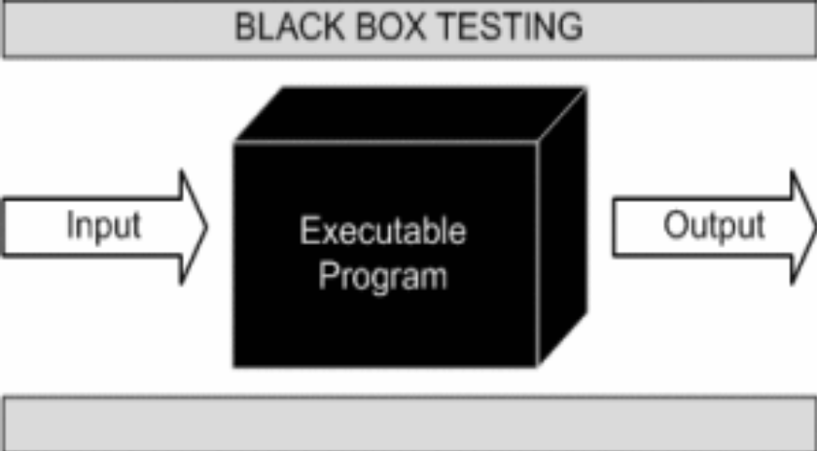

This method is named so because the software program, in the eyes of the tester, is like a black box; inside which one cannot see. This method attempts to find errors in the following categories:

- Incorrect or missing functions

- Interface errors

- Errors in data structures or external database access

- Behaviour or performance errors

- Initialization and termination errors.

White-Box Testing:

White Box Testing ,also known as Clear Box Testing, Open Box Testing, Glass Box Testing, Transparent Box Testing, Code-Based Testing or Structural Testing is a software testing method in which the internal structure/ design/ implementation of the item being tested is known to the tester.

The tester chooses inputs to exercise paths through the code and determines the appropriate outputs. Programming know-how and the implementation knowledge is essential.

White box testing is testing beyond the user interface and into the nitty-gritty of a system.
This method is named so because the software program, in the eyes of the tester, is like a white/ transparent box; inside which one clearly sees.

Limitations and Future Application of the Project

Futures Enhancement:
- In future we can expand this project on the web.
- In future, we can send messages to user on phone about different offers available.

Limitation :
In this, we don’t block the user.

Screen Snapshot

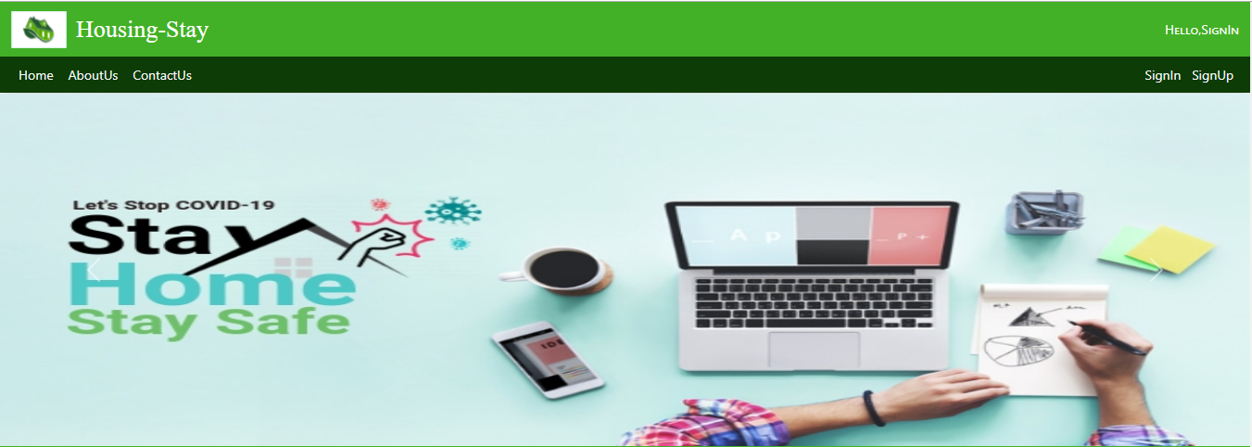

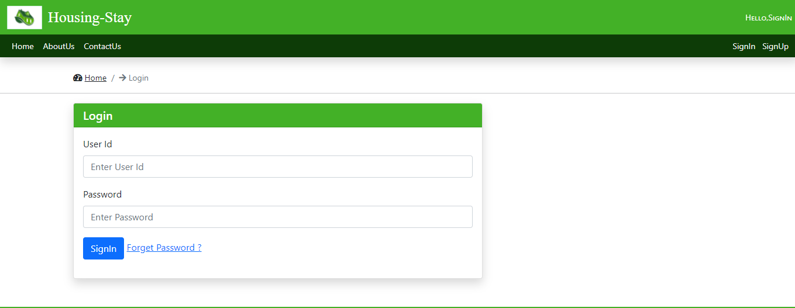
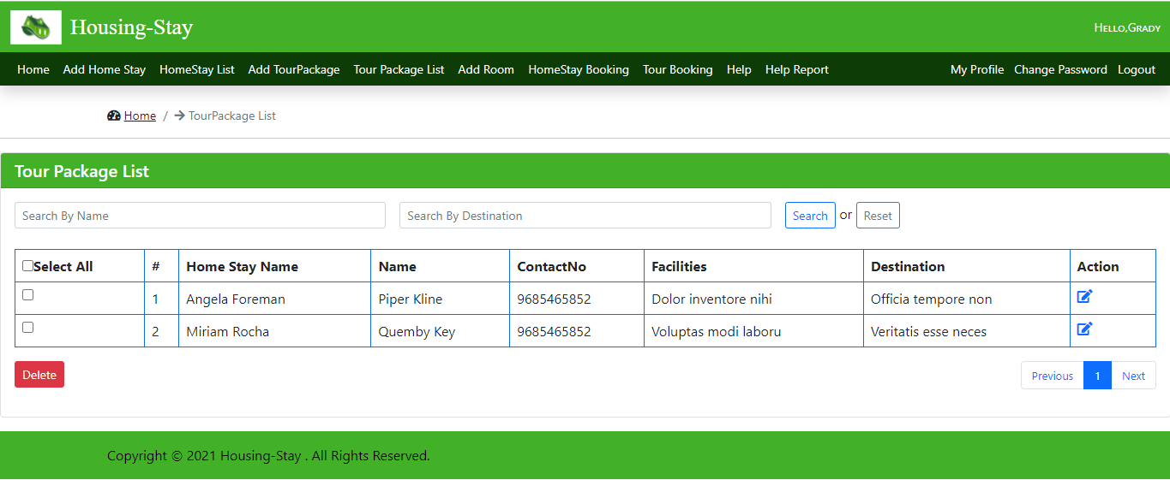
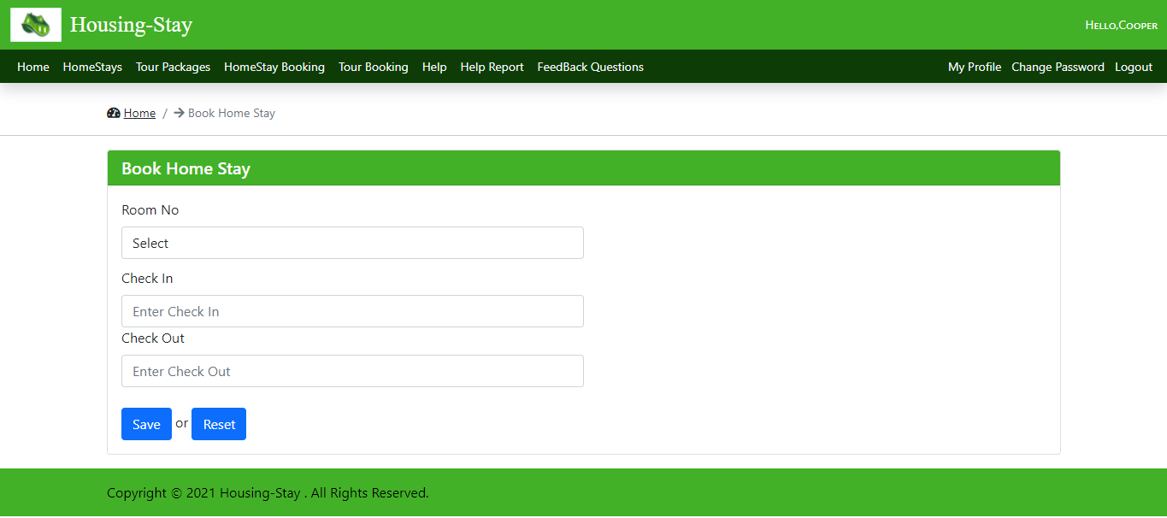

Conclusion

The Home stay application will help the travels to book the room in the home stay added by the owner in a more flexible way. No need of going to the place and booking using the traditional method instead of just replace it with our application.
This project can be used by the Home stays owners, travelers. It also provides a platform for owner to increase their business online.
This application is designed in such a way that any future modification can be done most easily.

